SE/WE Course Project
Main Document
for

[The Clinic Management System]

Submitted to
Dr. Abdelkareem Alashqar
Submitted in Partial Fulfillment of the Requirements for
Software Engineering Course – CSCI 2313
Web and Multimedia Engineering Course – WDMM 3314
By
[Raghad al sisi – 220221409]

December 2025

Abstract

[The Clinic Management System is a software solution designed to automate and manage the daily operations of a medical clinic. The system allows patient registration, storing medical records, appointment scheduling, prescriptions, billing, and overall clinic administration.
This document presents the project plan, requirements analysis, system design, implementation, and testing phases. The goal of this project is to improve clinic efficiency, reduce human errors, and provide a centralized digital system for managing all patient and administrative data.
The intended audience for this report includes clinic administrators, doctors, and staff who will use the system to manage patients, appointments, prescriptions, and billing.
The deliverables for this project include:
- Project plan (problem statement, project objectives, estimated effort, schedule, and risk analysis)
- System requirements and requirements collection methods
- UML design diagrams
- Implementation and testing results

Table of Contents

1. Chapter 1. Project Plan
1.1 Project Overview 1.2 Problem Statement 1.3 Project Objectives 1.4 Software Process Model 1.5 Team Organization 1.6 Risk Analysis 1.7 Hardware and Software Resource Requirements 1.8 Project Schedule

2. Chapter 2. System Requirements
2.1 System Overall Description 2.2 Main Use Case Diagram 2.3 System Specific Requirements 2.4 List of Classes 2.5 Non-Functional Requirements

3. Chapter 3. System Design
3.1 Application Architecture using Package Diagram 3.2 Modules (Packages) Descriptions

4. Chapter 4. System Implementation and Testing
4.1 Coding and Coding Standards 4.2 System Testing
5. References
Chapter 1. Project Plan

1.1 Project Overview
The current clinic operations rely heavily on manual processes and paper-based records.
This leads to several problems including difficulty in tracking patient history, errors in appointment scheduling, loss of medical records, delayed billing, and inefficient management of clinic resources.
There is a clear need for an integrated digital system that can centralize all clinic operations, reduce human errors, and improve overall efficiency and service quality.

1.2 Problem Statement
Many clinics still rely on manual and paper-based processes for managing daily operations and patient appointments. This approach causes several problems, including errors in appointment scheduling, difficulty in tracking patient history, lost or misplaced medical records, delayed billing, and inefficient management of staff and resources.
Additionally, patients often face challenges such as difficulty reaching the clinic during working hours, long waiting times, missed appointments, and administrative delays. Staff may struggle to accurately keep track of bookings and cancellations, increasing the administrative workload and reducing overall efficiency.
Therefore, there is a clear need for an automated, user-friendly system that centralizes all clinic operations, allows patients to manage their appointments based on the clinic’s defined schedules, reduces human errors, and improves both administrative efficiency and the quality of patient care.

1.3 Project Objectives
The main objectives of the Clinic Management System project are:
- To automate patient registration and record-keeping, reducing reliance on paper-based processes.
- To provide accurate and efficient appointment scheduling for patients and doctors.
- To maintain secure and organized medical records accessible to authorized staff.
- To automate billing and invoicing, reducing errors and delays.
- To improve overall clinic management and administrative efficiency.
- To provide a centralized digital system that minimizes human errors and enhances service quality.

1.4 Software Process Model
> For this project, we have selected the Waterfall Model as the software development process model.
This model is suitable because the system’s requirements are clearly defined and unlikely to change during development.
> For this project, the Waterfall Model was selected as the software development process model.
It is a linear and sequential model where each phase must be completed before the next begins.

> The Waterfall Model is suitable for this project because:
The requirements are clear and unlikely to change.
It provides a structured and easy-to-manage approach.
It’s ideal for academic and small to medium-sized projects.
Each phase can be reviewed and approved before proceeding.
Below is a diagram representing the Waterfall Model:

- Requirements
↓
- Analysis
↓
- Design
↓
- Implementation
↓
- Testing
↓
- Deployment
↓
- Maintenance

1.5 Team Organization

# | Name of Team Member | Main Responsibilities
1 | Raghad Al Sisi | System analysis
2 | Raghad Al Sisi | design
3 | Raghad Al Sisi | implementation
.. | Raghad Al Sisi | documentation

1.6 Risk Analysis
[Define risk and their types. For each potential risk identify its impact, probability, rank and risk plan. Complete the next risk plan table. For probability and impact use: Low, Mid, or High values. List the risks in a descending order based on rank. The number of the risk items is in the range of 5 to 10].

# | Risk Description | Probability | Impact | Rank | Risk Plan
1 | Internet connection failure during system use | Medium | High | 1 | Ensure offline backup procedures; notify user to retry.
2 | Bugs in appointment scheduling logic | High | High | 2 | Perform unit testing on all booking functions.
3 | Delays in development schedule | Medium | Medium | 3 | Set realistic milestones and weekly progress checks.
4 | Data loss due to system crash | Low | High | 4 | Use database backups and autosave mechanisms.
5 | Unauthorized access to patient data | Low | High | 5 | Implement authentication and role-based access.
6 | Misunderstanding of project requirements | Medium | Medium | 6 | Regularly review the requirements document.

1.7 Hardware and Software Resource Requirements
Hardware Requirements:
- A personal computer or laptop with at least 8GB RAM and 256GB storage.
- Internet connection.
- Web hosting server (optional for deployment).
Software Requirements:
- Web browser (e.g., Google Chrome, Firefox).
- Code editor (e.g., Visual Studio Code).
- XAMPP or any local server for testing (Apache + MySQL).
- PHP (for backend logic).
- HTML, CSS, JavaScript (for frontend).
- MySQL (for database).
- GitHub (for version control and backup).

1.8 Project Schedule
[Define the work breakdown structure of the project and project scheduling. Draw Gantt and
Network diagrams using suitable CASE tool (e.g. MS Project).]
1.8.1 Work Breakdown Structure
# | Task Name | Expected Time | Preceding Task (s)
1 | 1.8.2 Gantt Chart | 2 days | -- ---
2 | System Analysis | 3 days | 1
3 | System Design | 5 days | 2
4 | Implementation | 2 days | 3
5 | Database Integration | 2 days | 4
6 | Testing & Debugging | 2 days | 5
… | Documentation | 2 days | 6

1.8.2 Gantt Chart
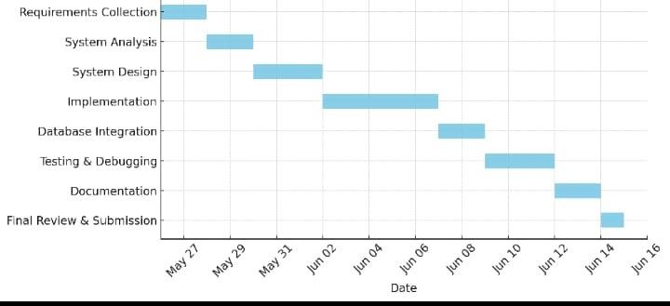

1.8.3 Network Diagram
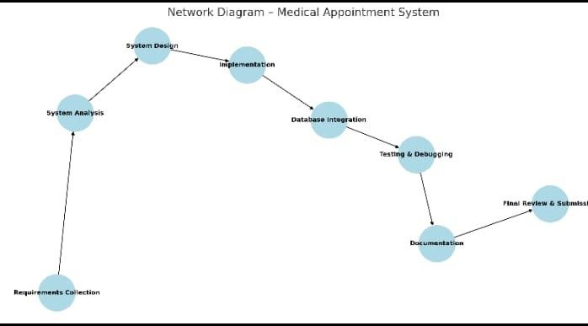

Chapter 2. System Requirements

2.1 System Overall Description
The Clinic Management System is a web-based system designed to manage the daily operations of a medical clinic. It helps in organizing patient information, scheduling appointments, managing medical records, and handling billing processes.
The system aims to replace manual and paper-based work with a centralized digital solution that reduces errors and improves efficiency. It allows different users such as administrators, doctors, and patients to access the system based on their roles, ensuring better coordination and improved quality of healthcare services.

2.2 Main Use Case Diagram
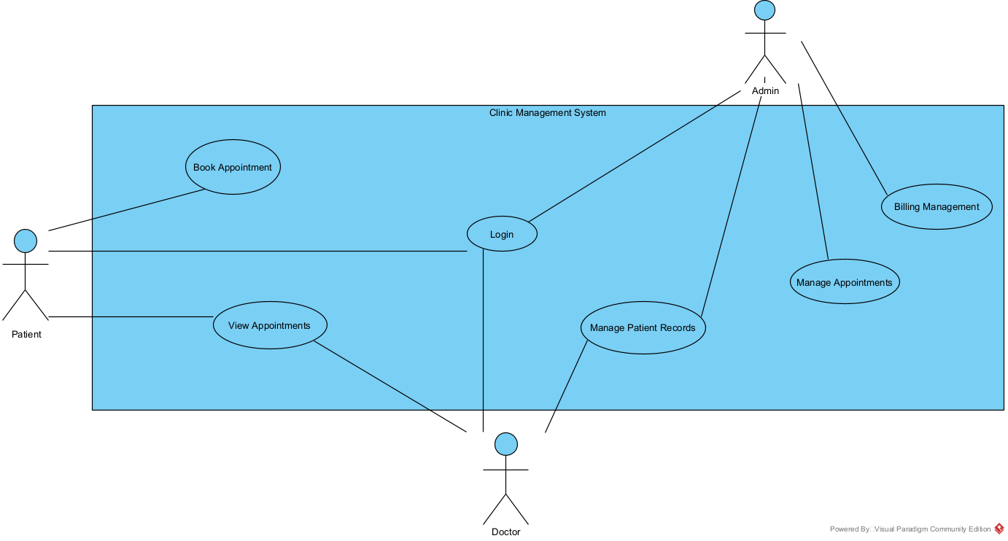

2.3 System Specific Requirements
[Describe in deep details the use cases using scenario format. Fill in the following table, and draw sequence diagram. Repeat for all uses cases appeared in Section 2.2] 2.3.1 Function Scenario for Login
ID |  | 1
Name |  |  | Login
Description |  |  | Allows users to log into the clinic management system using valid username and password.
Priority |  |  | Must have (1)
Actors |  |  | Patient, Doctor, Admin
Pre-Conditions |  |  | • User has a registered account in the system.
Flow of Events
Normal flow |  |  | 1. User enters username and password.  2. System verifies the entered credentials.  3. System grants access to the user.
Alternative flow |  |  | Alternative flow of events 1:  In Step 2, if the user enters invalid username or password,  the system displays an error message and asks the user to try again.
Post-Conditions |  |  | • User is successfully logged into the system.

]

2.3.1.1 Sequence Diagram for [logen]

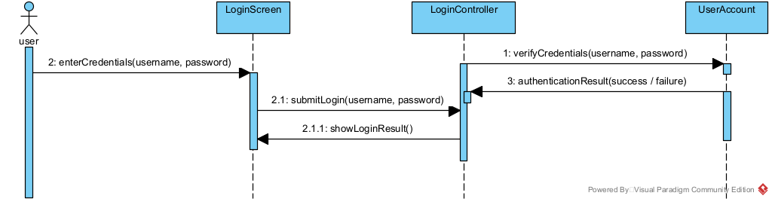

2.3.2 Function Scenario for [Book Appointment
ID |  | 2
Name |  |  | Book Appointment
Description |  |  | Allows the patient to book an appointment with a doctor based on available time slots.
Priority |  |  | Must have (1)
Actors |  |  | Patient
Pre-Conditions |  |  | • Patient is logged into the system.
Flow of Events
Normal flow |  |  | 1. Patient selects the book appointment option.  2. System displays available doctors and time slots.  3. Patient selects a doctor and an available time.  4. System confirms and saves the appointment.
Alternative flow |  |  | In Step 3, if the selected time slot is not available,  the system displays a message and asks the patient to choose another time.
Post-Conditions |  |  | • Appointment is successfully booked and stored in the system.

]

2.3.2.1 Sequence Diagram for [Book Appointment]

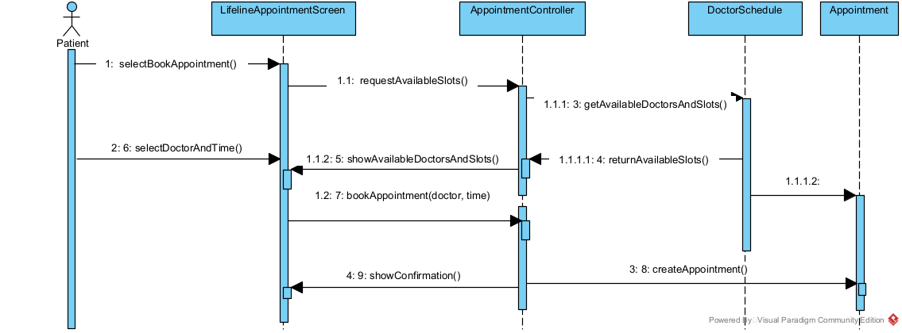

2.3.3 Function Scenario for [View Appointments
ID |  | 3
Name |  |  | View Appointments
Description |  |  | Allows users to view their scheduled appointments.
Priority |  |  | Should have (2)
Actors |  |  | Patient, Doctor
Pre-Conditions |  |  | • • User is logged into the system.
Flow of Events
Normal flow |  |  | 1. User selects the view appointments option.  2. System retrieves appointment data from the database.  3. System displays the list of appointments.
Alternative flow |  |  | In Step 2, if no appointments are found,  the system displays a message indicating that there are no appointments.
Post-Conditions |  |  | • • Appointments information is displayed to the user.

]

2.3.3.1 Sequence Diagram for [View Appointments]

2.3.4 Function Scenario for [Manage Appointments
ID |  | 4
Name |  |  | Manage Appointments
Description |  |  | Allows the administrator to manage clinic appointments by adding, updating, or deleting appointment records.
Priority |  |  | Must have (1)
Actors |  |  | Admin
Pre-Conditions |  |  | • Admin is logged into the system.
Flow of Events
Normal flow |  |  | 1. Admin selects the manage appointments option.  2. System displays the list of appointments.  3. Admin adds, updates, or deletes an appointment.  4. System saves the changes.
Alternative flow |  |  | In Step 3, if the selected appointment does not exist,  the system displays an error message.
Post-Conditions |  |  | • Appointment data is successfully updated in the system.

]

2.3.4.1 Sequence Diagram for [Manage Appointments]

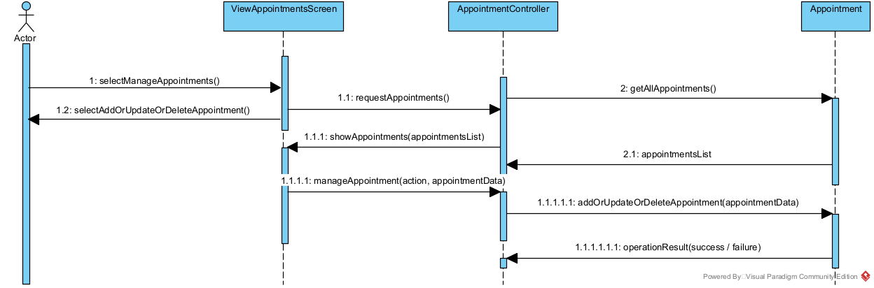

2.3.5 Function Scenario for [Manage Patient Records
ID |  | 5
Name |  |  | Manage Patient Records
Description |  |  | Allows authorized users to create, update, and view patient medical records.
Priority |  |  | Must have (1)
Actors |  |  | Doctor, Admin
Pre-Conditions |  |  | • User is logged into the system.  • Patient record exists in the system.
Flow of Events
Normal flow |  |  | 1. User selects a patient record.  2. System displays patient information.  3. User updates or reviews the patient record.  4. System saves the updated information.
Alternative flow |  |  | In Step 1, if the selected patient record does not exist,  the system displays an error message.
Post-Conditions |  |  | • Patient record is successfully updated and stored in the system.

]

2.3.5.1 Sequence Diagram for [Manage Patient Records]
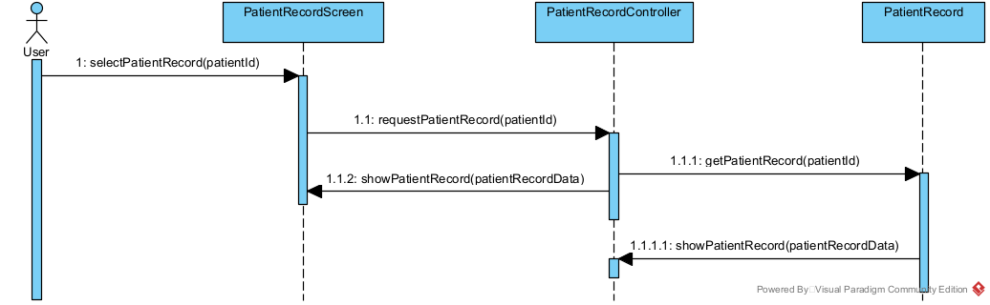

2.3.6 Function Scenario for [Billing Management
ID |  | 6
Name |  |  | Billing Management
Description |  |  | Allows the administrator to manage billing and payment records for patients.
Priority |  |  | Could have (3).
Actors |  |  | Admin
Pre-Conditions |  |  | • Admin is logged into the system.  • Patient appointment exists.
Flow of Events
Normal flow |  |  | 1. Admin selects the billing management option.  2. System displays patient billing information.  3. Admin generates or updates a bill.  4. System saves the billing record.
Alternative flow |  |  | In Step 2, if no billing information is found,  the system displays a message indicating no billing records are available.
Post-Conditions |  |  | • Billing information is successfully stored in the system.

2.3.6.1 Sequence Diagram for [Billing Management]

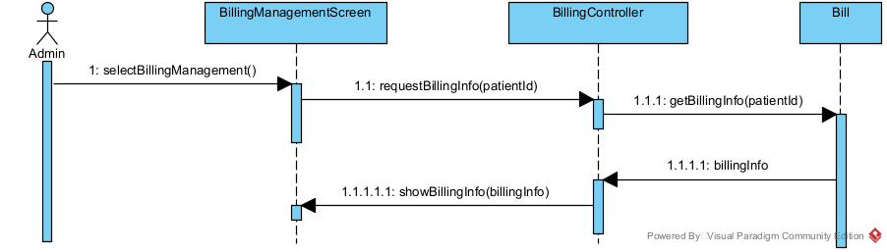

[Complete for all remaining functions.]

2.4 List of classes
[List and classify all classes that appear in the previous sequence diagrams in Section 2.3] 2.4.1 Interface (Boundary) classes
- LoginScreen
- ViewAppointmentsScreen
- LifelineAppointmentScreen
- BillingManagementScreen
- PatientRecordScreen

2.4.2 Entity classes
- UserAccount
- Appointment
- PatientRecord
- Bill
- DoctorSchedule

2.4.3 Control (Manager) classes
- LoginController
- AppointmentController
- BillingController
- PatientRecordController

2.5 Non-Functional Requirements
Usability:
The system shall be easy to use with a clear and simple user interface for all users.
Reliability:
The system shall store appointments, patient records, and billing data accurately without data loss.
Performance:
The system shall respond quickly to user actions such as login and viewing information.
Security:
The system shall protect sensitive data and allow access only to authorized users.

Chapter 3. System Design

3.1 Application Architecture using Package Diagram
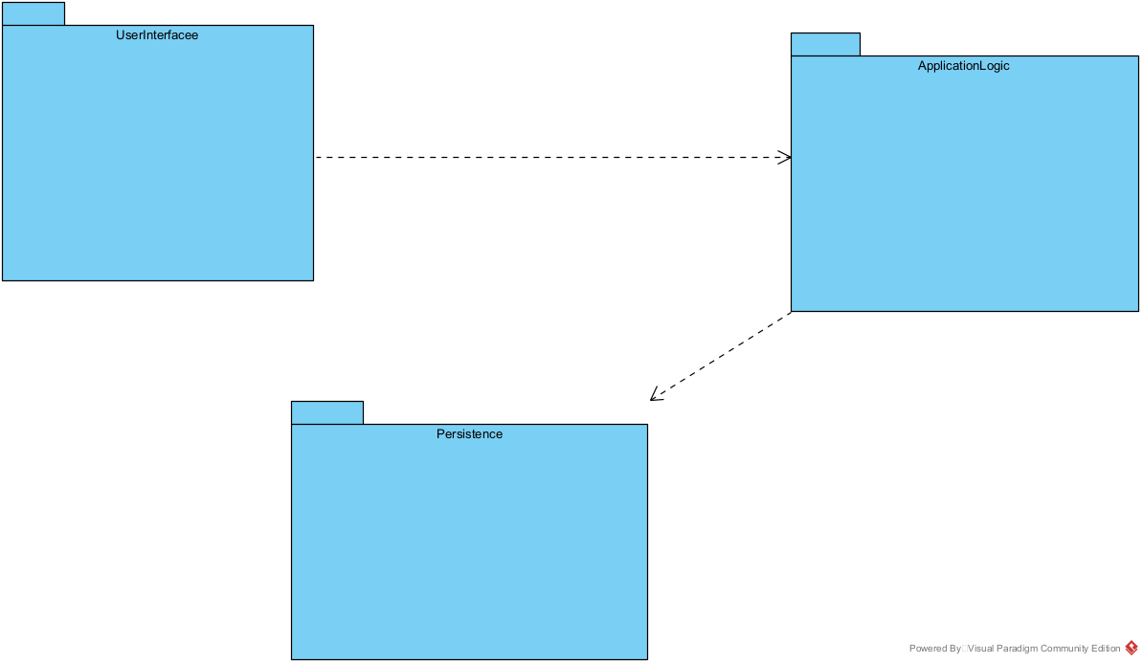

3.2 Modules (Packages) Descriptions
3.2.1 UserInterface Package
The UserInterface package handles user interaction with the system.
It includes all screens and forms used by the user, such as login, dashboard, patient data entry, appointments, and billing.
This package communicates with the ApplicationLogic package through the UIFacade class.

3.2.2 ApplicationLogic Package
The ApplicationLogic package contains the main business logic of the system.
It processes user requests, validates data, and controls system operations.
It acts as a link between the UserInterface and the Persistence package.

3.2.3 Persistence Package
The Persistence package is responsible for database access and data storage.
It manages saving and retrieving data and ensures data consistency.
This package is used by the ApplicationLogic package only.

3.2.1 UserInterface package
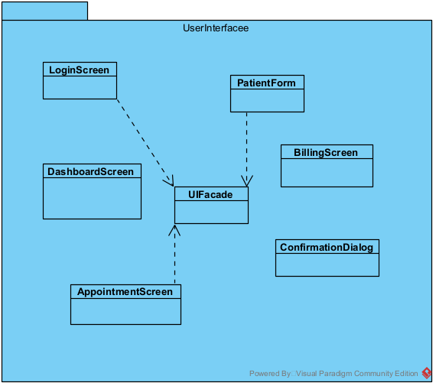

3.2.1.1 LoginScreen Class

Instance: LoginScreen
Attributes: username, password
Methods: displayLoginForm() ,submitLogin()

3.2.1.2 DashboardScreen Class

Instance: DashboardScreen
Attributes: username, notifications
Methods: displayDashboard(),navigateToModule()

3.2.1.3 PatientForm Class

Instance: PatientForm
Attributes: patientName, patientID, contactInfo
Methods: displayForm(),submitPatientData()

3.2.14AppointmentScreenClass

Instance: appointmentScreen
Attributes: appointmentDate, appointmentTime
Methods: showAppointments(),bookAppointment()

3.2.15BillingScreen Class

Instance: BillingScreen
Attributes: billAmount, paymentStatus
Methods: displayBill(),processPayment()

3.2.16ConfirmationDialog Class

Instance: Confirmation
Attributes: message
Methods: showMessage() ,confirmAction()

3.2.17 uiFacade Class

Instance: uiFacade
Attributes: appLogicReference
Methods: authenticateUser() sendRequest() receiveResponse()

3.2.2 ApplicationLogic packag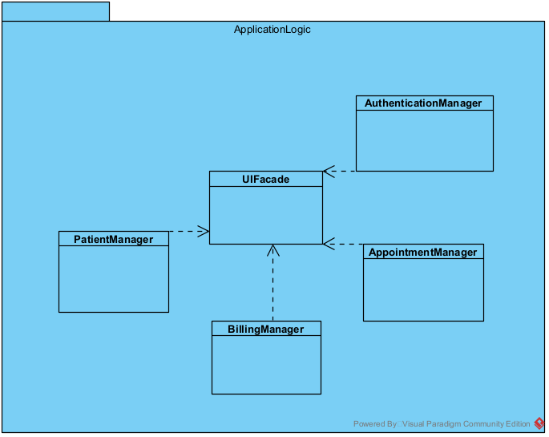e

3.2.2.1 UIFacade class
Instance: UIFacade

Attributes:
- authenticationManager
- patientManager
- appointmentManager
- billingManager

Methods:
- login()
- managePatients()
- manageAppointments()
- manageBilling()
3.2.2.2 AuthenticationManager class
Instance: AuthenticationManager

Attributes:
- usersList

Methods:
- authenticateUser()
- logout()

3.2.2.3 PatientManager class
Instance: PatientManager
Attributes:
- patientsList

Methods:
- addPatient()
- updatePatient()
- getPatient()

3.2.2.4 AppointmentManager class
Instance: AppointmentManager

Attributes:
- appointmentsList

Methods:
- scheduleAppointment()
- cancelAppointment()
- getAppointments

3.2.2.5 BillingManager class
Instance: BillingManager

Attributes:
- invoicesList

Methods:
- generateInvoice()
- processPayment()

3.2.3 Persistence package

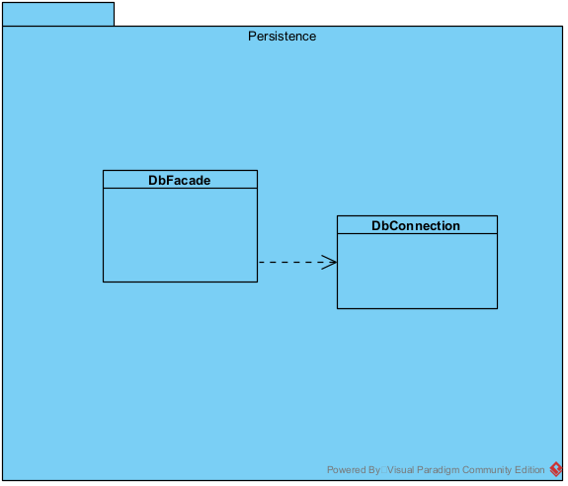

3.2.3.1 DbFacade class
Instance: DbFacade
Attributes:
- dbConnection
Methods:
- connect()
- executeQuery(query)
- closeConnection()

3.2.3.2 DbConnection class
Instance: DbConnection
Attributes:
- host
- dbName
- username
- password
- connection
Methods:
- open()
- close()
- getConnection()

Chapter 4. System Implementation and Testing

4.1 Coding and Coding Standards
This section presents snapshots of the implemented code for the main parts of the system.
The implementation focuses on core functionalities including the Login Screen, Patient Data Entry, Appointment Management, and Database Connectivity.
The system is implemented using PHP and follows a layered architecture.
The User Interface layer handles user input and displays information, while the Application Logic layer processes requests and applies business rules.
The Persistence layer is responsible for database connectivity and data storage.
Coding standards were followed to ensure clarity and maintainability of the code.
Classes and methods are named clearly according to their responsibilities.
Each class has a single responsibility, and comments are added to explain the purpose of important methods.

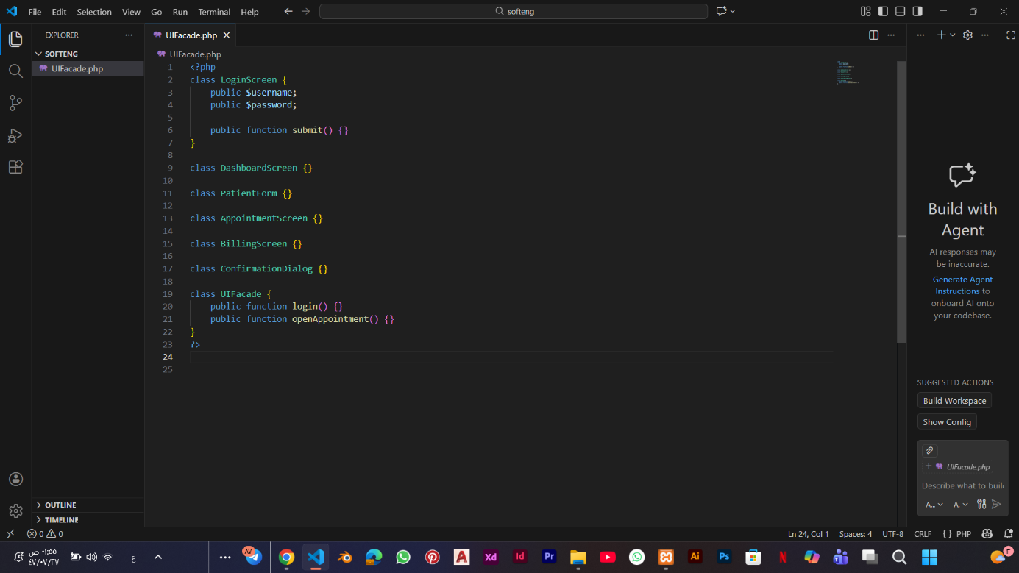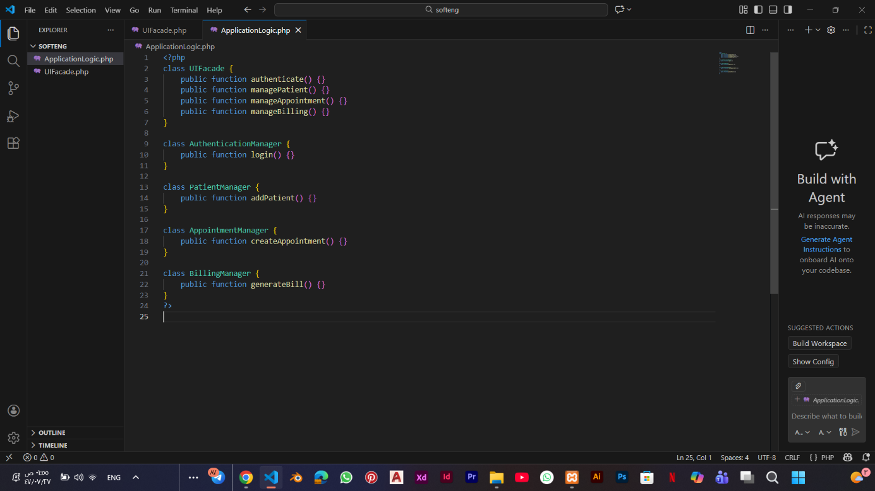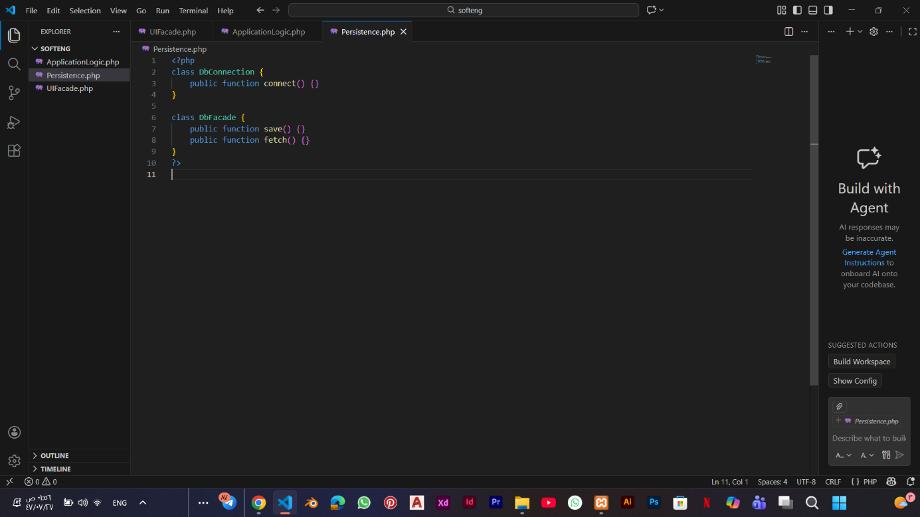

4.2 System Testing
The system was tested using different testing levels to ensure correct functionality.
Unit testing was used to test individual functions separately.
System testing was conducted to verify that all system components work together correctly.
Acceptance testing was performed to ensure that the system meets user requirements and works as expected.

4.2.1 Test Cases
[Define here the test cases for each system function that stated in Chapter 2 of this project.]
# | Function | Test Steps | Test Data | Expected Results | Actual Results | Status
1 |  |  | Valid credentials | User logged in successfully | User logged in successfully | Pass
  Login
  Enter valid username
2 |  | select view appointments option | User ID |  | Appointments list is displayed | Pass
  View
  Appointments
  Appointments list is displayed
3 | Manage Appointments | Add or update an appointment | Appointment details | Appointment saved successfully | Appointment saved successfully | Pass
4 | Manage Patient Records | Select patient record | Patient ID |  | Patient record displayed | Pass
  Patient record displayed
5 | Billing Management | View billing information |  |  | Billing details displayed | Pass
  Patient ID
  Billing details displayed
6
…

5. References
[1] Ian Sommerville, “Software Engineering,” 10th Edition, Pearson Education, 2016.

[2] Object Management Group (OMG), “Unified Modeling Language (UML) Specification,”
Formal Standard Documentation, https://www.omg.org/spec/UML/, Accessed on 16/01/2026.

[3] Visual Paradigm, “UML Modeling and Software Design Documentation,”
Formal Website, https://www.visual-paradigm.com/, Accessed on 16/01/2026.

[4] PHP Group, “PHP Official Documentation,”
Formal Website, https://www.php.net/docs.php, Accessed on 16/01/2026.

[5] Oracle Corporation, “Database Concepts and SQL Fundamentals,”
Formal Domentation, https://docs.oracle.com/en/database/, Accessed on 16/01/2026.

